1.)
SELECT MAX(total), InvoiceId

FROM invoices
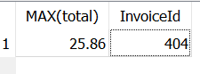

2.)

SELECT
BillingCity,
(COUNT(InvoiceId))
FROM
invoices
GROUP BY
BillingCity
ORDER By (COUNT(InvoiceId)) DESC;



Wäre es möglich auch mit „MAX” Befehl?

3.)
SELECT media_types.Name, tracks.MediaTypeId, Count(*)
From Tracks
LEFT JOIN media_types
ON tracks.MediaTypeId = media_types.MediaTypeId
WHERE media_types.MediaTypeId='2';
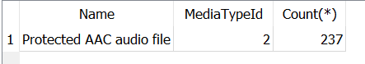

4.)
SELECT artists.Name, COUNT(Name)
From artists
LEFT JOIN albums
ON artists.ArtistId = albums.ArtistId
Group by name
order by count(name) desc;
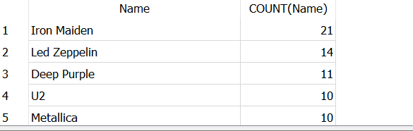

5.) SELECT genres.name, COUNT(tracks.TrackId)
From genres
LEFT JOIN tracks
ON genres.GenreId = tracks.GenreId
Group by genres.GenreId
order by count(TrackId) desc
;

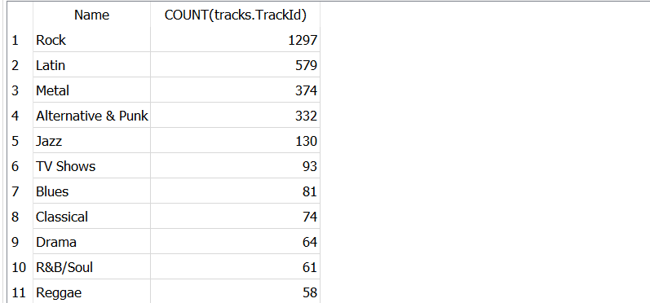

6.)
SELECT customers.FirstName, customers.LastName, SUM(total)
From customers
LEFT JOIN invoices
ON customers.CustomerId = invoices.CustomerId
Group by invoices.CustomerId
order by SUM(total) desc;
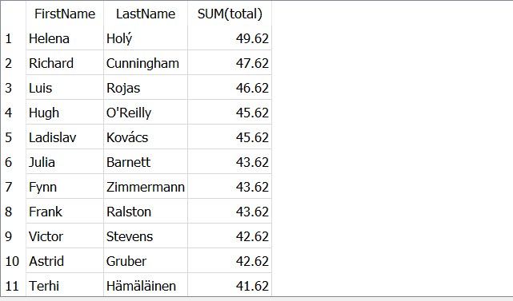

7.)
SELECT InvoiceId, InvoiceLineId, invoice_items.TrackId, Tracks.Name
From invoice_items
LEFT JOIN tracks
ON invoice_items.TrackId = tracks.TrackId
Group by InvoiceLineId;



